CHAPTER 3: Cells
Worksheet 3.1

History of the light microscope
Answers
Read the following text and answer the questions that follow.  Before the invention of the microscope, biologists did not know that living things were made of cells. The first light microscopes were built from spectacle lenses and tubes by Zaccharias Janssen and his father Hans in Holland between 1590 and 1610. In 1665, Robert Hooke used a simple microscope that magnified by 30× to observe thin slices of cork. He found structures that reminded him of the boxes or cells of a honeycomb, and so he called them cells.  He examined other plant tissue in later experiments and observed that some of these cells contained a fluid. In the 1670s and 1680s Antonie van Leeuwenhoek, using a single lens microscope, observed cellular life forms (or protozoa) in sea water and rainwater. He identified microbes such as yeast and bacteria. His lenses were superior to those of Hooke because he had trained as a lens grinder and polisher. Magnifications of about 270× were achieved due to the great radius of curvature of his lenses. (The radius of curvature of a lens is a measure of how curved it is.)  It was not until the middle of the nineteenth century that significant improvements were made to optical microscopes so that greater magnification and resolution could be achieved. The American Charles Spencer developed a company that produced light microscopes with magnification up to 1250×. By using blue light, the magnification was increased to 5000×. Throughout the twentieth century, further improvements in lens manufacture, improving contrast and the use of specialised dyes to stain tissue led to improved images of living matter. | 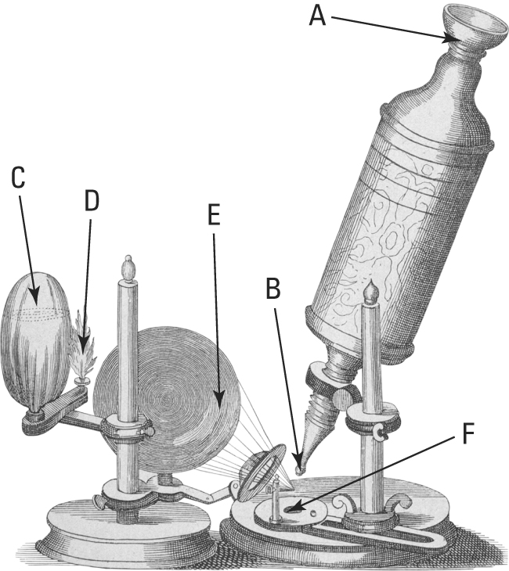  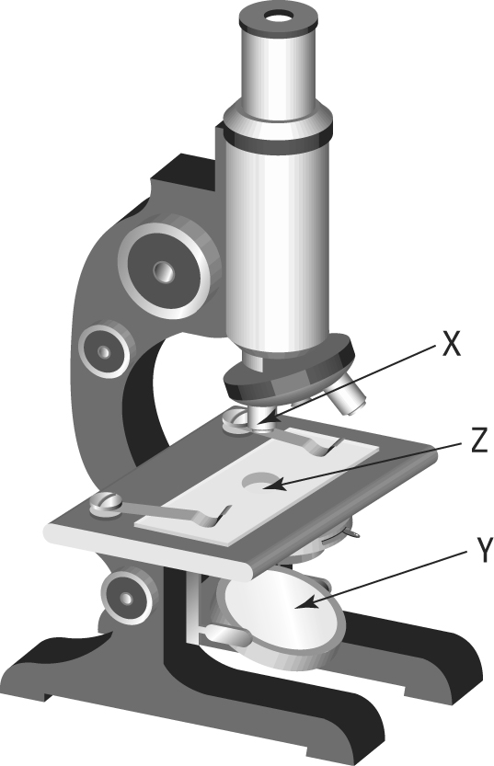
1. Explain how the term ‘cell’ first came into use.
The structures reminded Robert Hooke of the boxes or cells of a honeycomb.
Yeast and bacteria
2. Identify the first microbes that were observed using a light microscope.
3. Identify factors that improve the magnification of a light microscope.
Greater lens curvature; better grinding procedures; use of blue light

4. The top figure shows a microscope used by Robert Hooke. Identify which components (A to F) correspond to the list below:
B
D
F
Specimen : …………….…...... Light source: …………….… Objective lens: …………….…..
A
E
C
Eyepiece lens: …………….… Mirror: …………….…......... Light focus lens: …………….…
5. The bottom drawing shows a modern student microscope. Three components (X, Y and Z) are labelled. Match these letters to the letters in the Hooke microscope drawing.
F
C
B
X: …………….… Y: …………….… Z: …………….…

